  Electronics corp. | HC-870T1608B  HANSE SENSOR SERIES | Spec. No. | HP-L217
 | 870nm INFRARED LED | Part  2017Rev : 1.0 | LED

SPECIFICATION

CUSTOMER :
DEVICE NAME :
MODEL NO. :
ISSUED DATE :

[ CUSTOMER APPROVAL ]
APPROVAL NO.
APPROVAL DATE
APPROVAL | INSPECTER | CHECK | APPROVAL | COMMENT
[ SUPPLIER ]
ISSUED DEPT. | ISSUE | REVIEW | REVIEW | APPR’D

HANSE ELECTRONICS CORP.
TEL : 82-31-206-2851 FAX : 82-31-206-2850
http://www.e-hanse.com
HESP-KA-034
1/13
2017Rev : 1.0  HC-870T1608B  Electronics corp.  HANSE SENSOR SERIES |  | Spec. No. | HP-L217
 | 870nm INFRARED LED | Part | LED

- CONTENTS -


1. FEATURES

2. OUTLINE DIMENSIONS

3. SPECIFICATIONS

4. COMPOSITION OF DEVICE

5. ELECTRO-OPTICAL CHARACTERISTICS CURVES

6. RELIABILITY

7. TAPING

8. PACKING

9. CUATIONS

HANSE ELECTRONICS CORP.
TEL : 82-31-206-2851 FAX : 82-31-206-2850
http://www.e-hanse.com
HESP-KA-034
2/13
2017Rev : 1.0  HC-870T1608B  Electronics corp.  HANSE SENSOR SERIES |  | Spec. No. | HP-L217
 | 870nm INFRARED LED | Part | LED


1. FEATURES
HC-870T1608B
▪ SMD Top View type
▪ 870nm Infrared Emitting
GaN
▪ High Radiant Intensity
▪ Viewing angle : Lambertian emitter(120˚)
▪ Package size : 1.6 × 0.8 × 0.4
▪ Reliability test completion
▪ Suitable for all SMT
assembly methods

2. OUTLINE DIMENSIONS


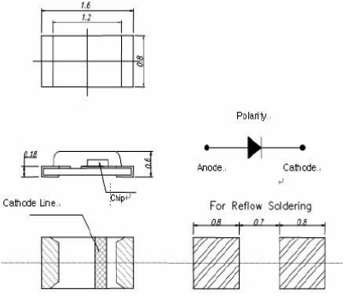
(Unit : mm)

HANSE ELECTRONICS CORP.
TEL : 82-31-206-2851 FAX : 82-31-206-2850
http://www.e-hanse.com
HESP-KA-034
3/13
5.0
2-□0.5

2017Rev : 1.0  HC-870T1608B  Electronics corp.  HANSE SENSOR SERIES |  | Spec. No. | HP-L217
 | 870nm INFRARED LED | Part | LED

3. SPECIFICATIONS

▣ Absolute Maximum Rating
(Ta=25℃)
Parameter | Symbol | Value | Unit
Power Dissipation | P_{D} | 120 | ㎽
Peak Forward Current ^{▶ 1} | I_{FP} | 0.5 | A
Reverse Voltage | V_{R} | 5 | V
Forward Current | I_{F} | 80 | ㎃
Operating Temperature | Topr | -35 to + 85 | ℃
Storage Temperature | Tstg | -40 to + 85 | ℃
Soldering temperature | Tsol | Reflow soldering : 240℃, 10 sec  Hand Soldering : 300℃, 3 sec
▶ 1 : Duty Ratio ≤ 1/100, Pulse Width ≤ 0.01 msec.

▣ Electro-Optical Characteristics
(Ta=25℃)
Parameter | Symbol | Condition | Min | Typ | Max | Unit
Forward Voltage | V_{F} | I_{F}=20㎃ | - | 1.4 |  | V
Reverse Current | I_{R} | V_{R}=5V | - | - | 10 | ㎂
Radiant Intensity | Po | I_{F}=20㎃ | - | 5 | - | mW
Viewing Angle ^{▶ 3} | 2θ_{1/2} | I_{F}=20㎃ | - | ±60 | - | deg.
Peak Wavelength | λ_{P} | I_{F}=20㎃ | - | 870 | - | nm

▶ 3 : θ_{1/2} is the off-axis angle at which the luminous intensity is half the peak intensity.
※ Measurement Uncertainty : ± 10%

HANSE ELECTRONICS CORP.
TEL : 82-31-206-2851 FAX : 82-31-206-2850
http://www.e-hanse.com
HESP-KA-034
4/13
2017Rev : 1.0  HC-870T1608B  Electronics corp.  HANSE SENSOR SERIES |  | Spec. No. | HP-L217
 | 870nm INFRARED LED | Part | LED

4. COMPOSITION OF DEVICE

A. MATERIALS OF PACKAGE
Number | Item | Material
1 | Die adhesive | Ag Epoxy
2 | LED Chip | AlGaAs
3 | Au Wire | 1.0mil
4 | Mold epoxy | Epoxy Resin
5 | Electrodes | Au Plating Cu Alloy

B. DIAGRAM OF COMPOSITION

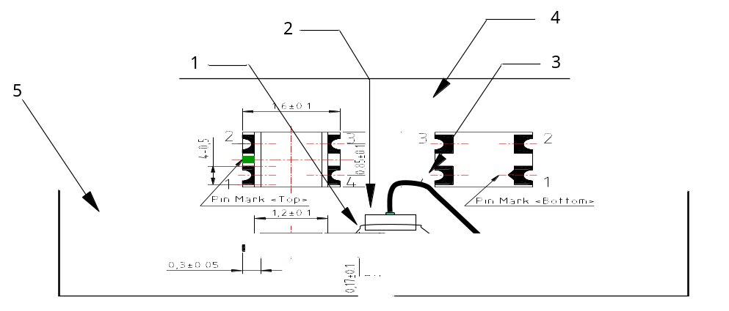

HANSE ELECTRONICS CORP.
TEL : 82-31-206-2851 FAX : 82-31-206-2850
http://www.e-hanse.com
HESP-KA-034
5/13
`  2017Rev : 1.0  HC-870T1608B  Electronics corp.  HANSE SENSOR SERIES |  | Spec. No. | HP-L217
 | 870nm INFRARED LED | Part | LED

5. ELECTRO-OPTICAL CHARACTERISTICS CURVES

■ Forward Current Vs. Relative Luminosity

■ Forward Voltage Vs. Forward Current

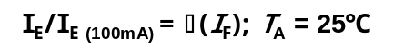

Function :

Function :

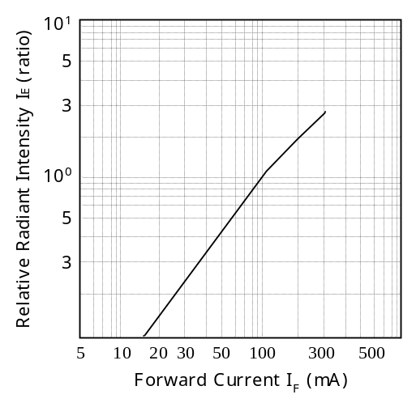
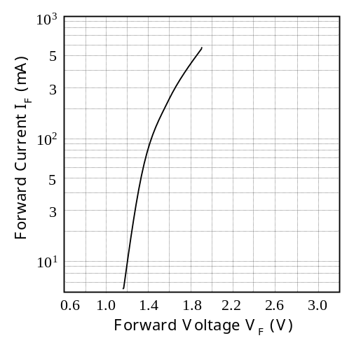

■ Forward Current Derating Curve

■ Relative Luminosity Vs. Ambient Ta(℃)


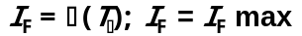
Function :

Function :

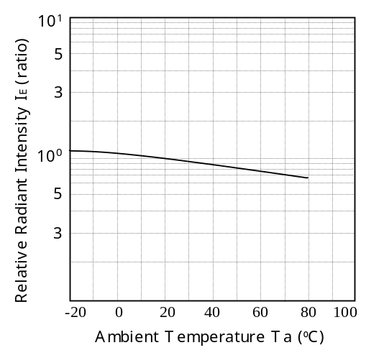

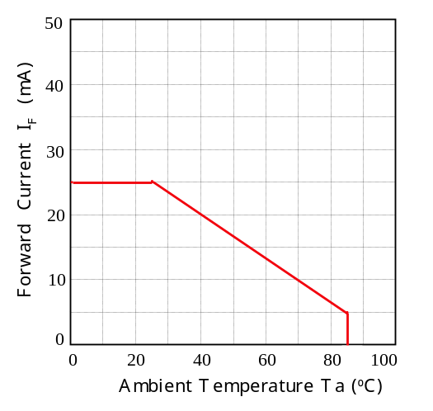

HANSE ELECTRONICS CORP.
TEL : 82-31-206-2851 FAX : 82-31-206-2850
http://www.e-hanse.com
HESP-KA-034
6/13

2017Rev : 1.0  HC-870T1608B  Electronics corp.  HANSE SENSOR SERIES |  | Spec. No. | HP-L217
 | 870nm INFRARED LED | Part | LED

5. ELECTRO-OPTICAL CHARACTERISTICS CURVES

■ Radiation Characteristics

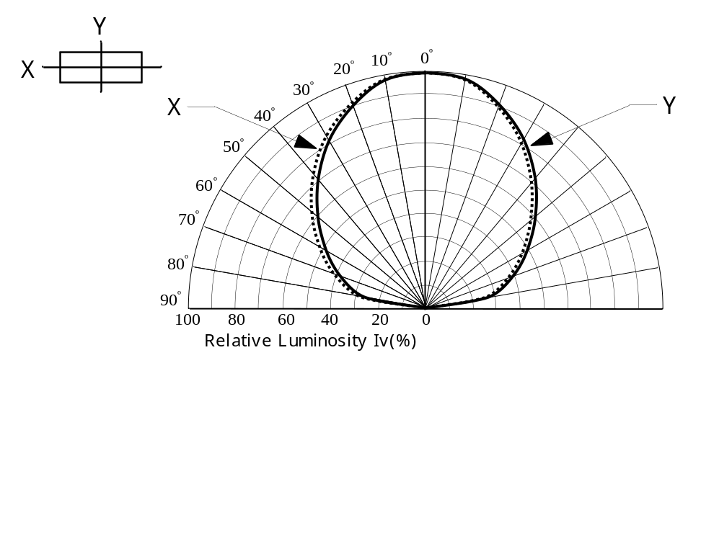

■ Relative Radiant intensity vs. Wavelength

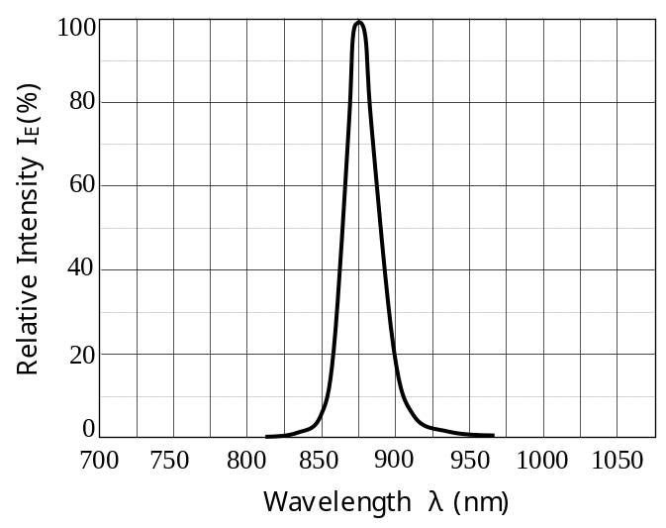

HANSE ELECTRONICS CORP.
TEL : 82-31-206-2851 FAX : 82-31-206-2850
http://www.e-hanse.com
HESP-KA-034
7/13

2017Rev : 1.0  HC-870T1608B  Electronics corp.  HANSE SENSOR SERIES |  | Spec. No. | HP-L217
 | 870nm INFRARED LED | Part | LED

6. RELIABILITY

A. TEST ITEMS AND RESULTS
Test Item | Standard  test method | Test Conditions | Note | Number of Damaged
Resistance  to Soldering Heat (Reflow Soldering) | JEITA ED-4701  300 301 | Tsol=240℃, 10sec.  (Pre treatment 30℃, 70%, 168hrs.) | 2 times | 0/50
Solderability  (Reflow Soldering) | JEITA ED-4701  100 105 | Tsol=215±5℃, 3sec. | 1 time  over 95% | 0/50
Heat Shock | JEITA ED-4701  100 105 | 0℃ ~ 100℃  5sec. 15sec. | 20 cycles | 0/50
Temperature Cycle | JEITA ED-4701  100 105 | -40℃ ~ 25℃ ~ 100℃ ~ 25℃  15min. 5min. 15min. 5min. | 100 cycles | 0/50
High Humidity Heat Cycle | JEITA ED-4701  200 203 | 30℃ ~ 65℃ ~ -10℃  90%RH 24hrs./1cycle | 10 cycles | 0/50
High Temperature  Storage | JEITA ED-4701  200 203 | Ta=100℃ | 1000 hrs. | 0/50
Humidity Heat  Load | JEITA ED-4701  100 103 | Ta=60℃, RH=90% | 1000 hrs. | 0/50
Low Temperature  Storage | JEITA ED-4701  200 202 | Ta=-40℃ | 1000 hrs. | 0/50
Life Test  Condition 1 |  | Ta=25℃, IF=20mA | 1000 hrs. | 0/50
High Temperature  Life Test |  | Ta=85℃, IF=5mA | 1000 hrs. | 0/50
High Humidity  Heat Life Test |  | 60℃, RH=90%, IF=15mA | 500 hrs. | 0/50
Low Temperature  Life Test |  | Ta=-30℃, IF=20mA | 1000 hrs. | 0/50

B. CRITERIA FOR JUDGING THE DAMAGE
Item | Symbol | Test Conditions | Criteria for Judgement
Item | Symbol | Test Conditions | Min. | Max.
Forward Voltage  Reverse Current  Luminous Intensity | VF  IR  IV | IF=20mA  VR=5V  IF=20mA | -  -  L.S.L.**) × 0.7 | U.S.L.*) × 1.1  U.S.L.*) × 2.0  -
*) U.S.L. : Upper Standard Level **) L.S.L. : Lower Standard Level

HANSE ELECTRONICS CORP.
TEL : 82-31-206-2851 FAX : 82-31-206-2850
http://www.e-hanse.com
HESP-KA-034
8/13

2017Rev : 1.0  HC-870T1608B  Electronics corp.  HANSE SENSOR SERIES |  | Spec. No. | HP-L217
 | 870nm INFRARED LED | Part | LED

7. TAPING

A. Dimension of Tape ( Material : PS Carbon, 10E5Ω )

(Unit : mm)
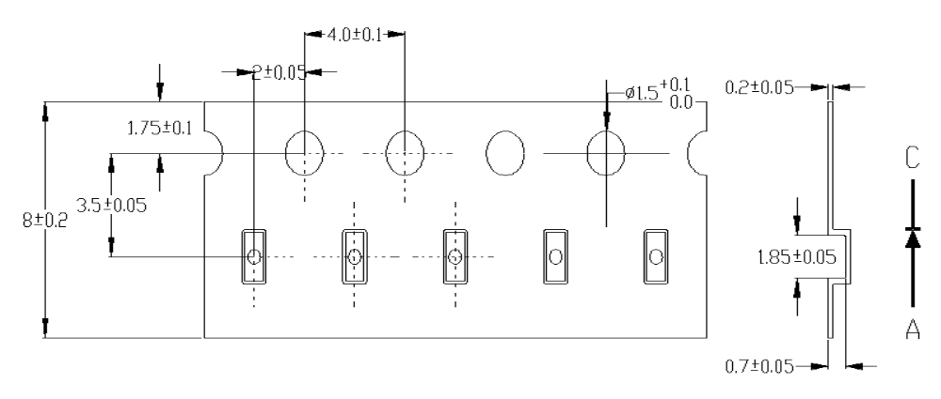

0.85±0.05

B. Dimension of Wheel ( Material : PS Conductive, 10E9~12Ω )

(Unit : mm)
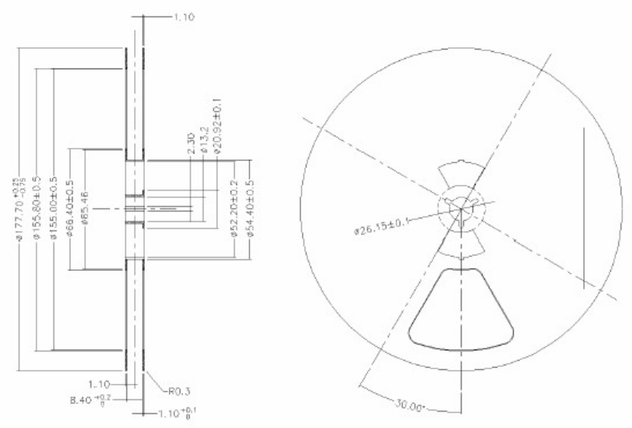

Loading quantity
per reel
: 4,000pcs

HANSE ELECTRONICS CORP.
TEL : 82-31-206-2851 FAX : 82-31-206-2850
http://www.e-hanse.com
HESP-KA-034
9/13
`  2017Rev : 1.0  HC-870T1608B  Electronics corp.  HANSE SENSOR SERIES |  | Spec. No. | HP-L217
 | 870nm INFRARED LED | Part | LED

8. PACKING

A. Packing diagram

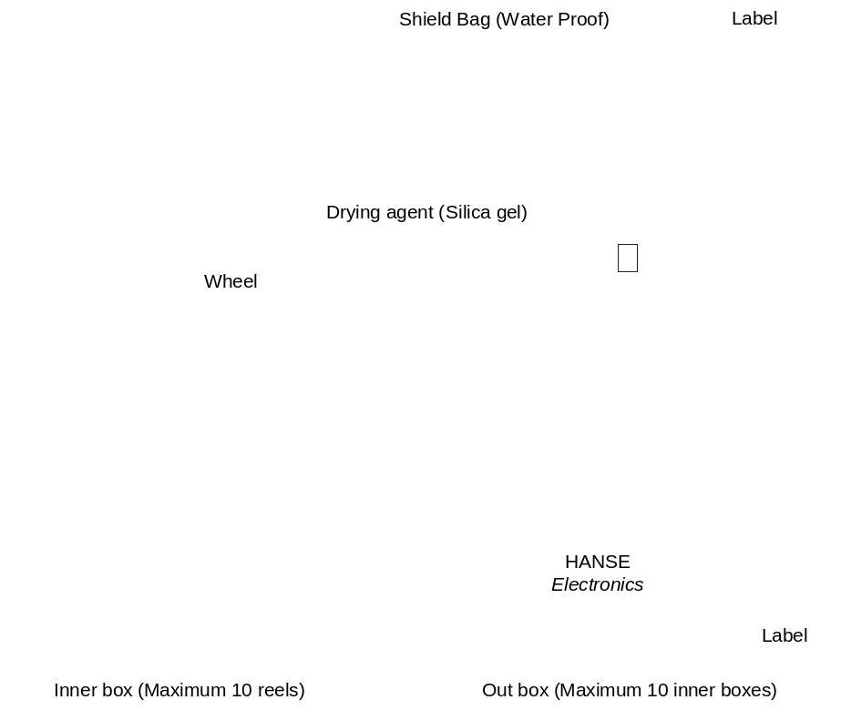

5.0
2-□0.5

B. Precaution
A. The label on the minimum packing unit shows : Part Number, Lot Number, Ranking, Quantity
In order to protect the LEDs from mechanical shock, we pack them in cardboard boxes for
transportation.
B. The LEDs may be damaged if the boxes are dropped or receive a strong impact against them,
so precautions must be taken to prevent any damage.
C. The boxes are not water resistant and therefore must be kept away from water and moisture.
When the LEDs are transported, we recommend that you use the same packing method as
HANSE Electronics

HANSE ELECTRONICS CORP.
TEL : 82-31-206-2851 FAX : 82-31-206-2850
http://www.e-hanse.com
HESP-KA-034
10/13

`  2017Rev : 1.0  HC-870T1608B  Electronics corp.  HANSE SENSOR SERIES |  | Spec. No. | HP-L217
 | 870nm INFRARED LED | Part | LED

9. CUATIONS

(1) Moisture Proof Package
  - When moisture is absorbed into the LEDs it may vaporize and expand during soldering. There is a possibility that this can cause the exfoliation of the contacts and the damage the optical characteristics of the LEDs. For this reason, the moisture proof package is used to keep moisture to a minimum in the package.
  - After opening the package, the LEDs should be kept at 30℃, 40~70%RH.
The LEDs should be soldered within 168 hours(7days) after opening the package.
- When storing the LEDs after opening the package, use a sealable away from package with a moisture absorbent material(Silica gel) inside.
- If the blue color of the desiccant indicator has faded after storing, a baking treatment should be performed as follows : 65 ± 5℃ for more than 24 hours.

(2) Soldering Conditions
- The LEDs can be soldered in place using the reflow soldering method.
- The recommended soldering conditions are as follows:

Reflow Soldering |  |  | Hand Soldering
 | Lead Solder | Lead-free Solder
Pre-heat | 120~150℃ | 180~200℃ | Temperature | 350℃ Max
Pre-heat time | 120sec Max | 120sec Max | Soldering time | 3sec Max
Peak temperature | 240℃ Max | 260℃ Max |  | (one time only)
Soldering time | 10sec Max | 10sec Max
Condition | refer to | refer to
 | Temperature | Temperature
 | profile ① | profile ②
* After reflow soldering rapid cooling should be avoided.

HANSE ELECTRONICS CORP.
TEL : 82-31-206-2851 FAX : 82-31-206-2850
http://www.e-hanse.com
HESP-KA-034
11/13
2017Rev : 1.0  HC-870T1608B  Electronics corp.  HANSE SENSOR SERIES |  | Spec. No. | HP-L217
 | 870nm INFRARED LED | Part | LED

- Temperature-Profile
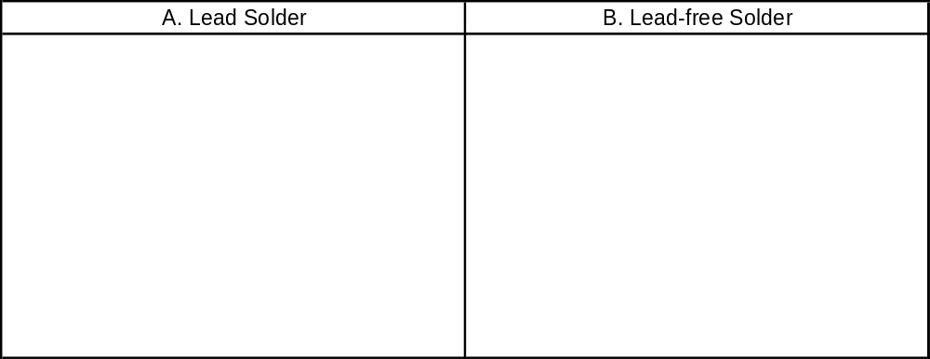

- Recommended Soldering

(Unit : mm)

- Modifications should not be done after the LEDs have been soldered.
If modifications cannot be avoided, a double-head soldering iron should be used after checking whether the characteristics of the LEDs will not be damaged by modification after soldering.
- Reflow soldering, do not apply force to the package during heating.
- After soldering, do not warp the circuit board.

(3) Heat Generation
- Heat generation must be taken into design consideration when using the LEDs.
The coefficient of temperature increase per input electric power is about 0.62℃/mW at the LED’s active layer. This coefficient will be affected by the heat resistance of the circuit board and by dense mounting of the LEDs. At the same time, precautions must be taken into the design of circuitry to avoid intense heat generation. Proper designs which allow radiation of heat, etc. may be needed.

HANSE ELECTRONICS CORP.
TEL : 82-31-206-2851 FAX : 82-31-206-2850
http://www.e-hanse.com
HESP-KA-034
12/13
2017Rev : 1.0  HC-870T1608B  Electronics corp.  HANSE SENSOR SERIES |  | Spec. No. | HP-L217
 | 870nm INFRARED LED | Part | LED

(4) Static Electricity
- Static Electricity and surge damages the LEDs. It is recommended to use a wrist band or anti-electrostatic glove when handling the LEDs.
- All devices, equipment and machinery must be properly grounded.
- When inspecting own final products on which LEDs were mounted, it is recommended to check also whether the mounted LEDs are damaged by static electricity or not.
- Damaged LEDs will show some unusual characteristics such as leak current remarkably increases, starting forward voltage becomes lower, or the LEDs get unlighted at the low current.

(5) Cleaning
- Use Isopropyl Alcohol as a solvent for cleaning the LEDs. Using other solvents may dissolve the LED package and the epoxy. Caution is needed.
Ultrasonic cleaning of the LEDs should not be done.

(6) Others
- The electrode sections are plated with silver. Those will become discolored by contact with corroded gas etc. Precautions must be taken to maintain a clean storing atmosphere.
- These LEDs described in this brochure are intended to be used for ordinary electronic equipment. Consult HANSE’s sales staff in advance for information on the applications in which exceptional quality and reliability are required, particularly when the failure or malfunction of the LEDs may directly jeopardize life or health (such as airplanes, aerospace, automobiles, life support systems and safety devices).
- User shall not reverse engineer by disassembling or analysis of the LEDs without having the prior written consent of HANSE. When defective LEDs are found, User shall inform to HANSE directly before disassembling or analysis.
- The appearance and specifications of the product may be modified for improvement without notice.

HANSE ELECTRONICS CORP.
TEL : 82-31-206-2851 FAX : 82-31-206-2850
http://www.e-hanse.com
HESP-KA-034
13/13

